MACHINE LEARNING
PYTHON 07
SET PRACTICE QUESTION 01
ABHAY RAJ
Date: 22 june 2026

Q. write a program to create a set and add a new element to it, remove an element using remove(), and discard element using discard().
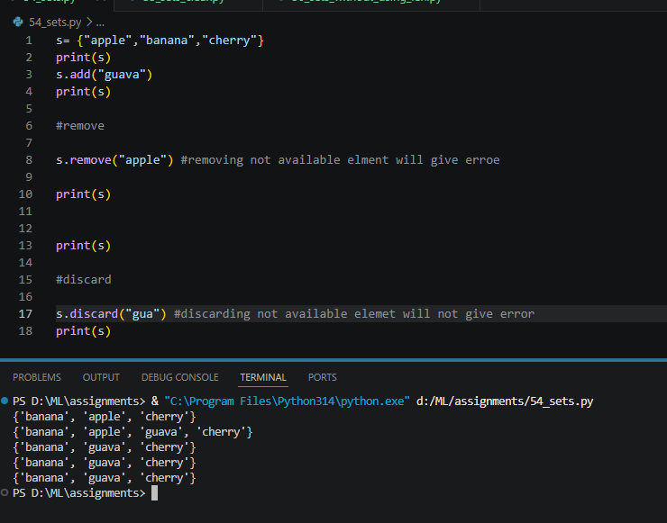

Q. write a program to remove all elemnts from set using clear().
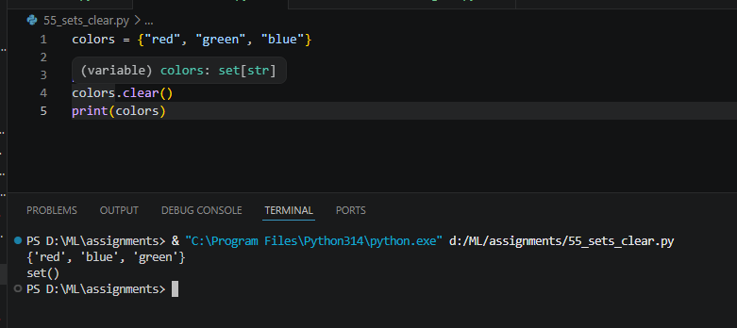

Q. write a python program to determine how many elements are in a set without using built in len() function.
